STAT 301 Homework 5 Name Charles Sandahl
- A researcher has randomly selected a sample of 8 adults to participate in a memory study. Each adult is administered a treatment and then given a memory test. The memory test scores are standardized. A higher score indicates a better memory score. The data is shown below. Use the 0.05 significance level to test that there is a significant mean difference between the test scores of taking the three treatments, by answering the following questions.
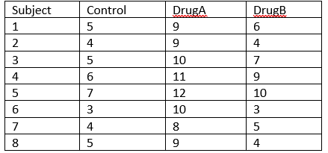
a) Formulate the null and alternative hypotheses to test the differences of the treatments.
$$H_{0}: μ_{control} = μ_{drugA}= μ_{drugB}$$
$$H_{a}:At least two means are different$$

b) What are the F statistic and the p-value? What do you conclude based on the significance level of 0.05?
$$F-Value=50.6185$$
$$p-value=<.0001$$
The p-value is 0.0001, which is significantly lower than our 𝛼-value of 0.05, so we reject the null hypothesis which suggests that there is evidence that the mean difference in test scores are significantly different among the three treatments.

- If there is a significant difference between treatments, which two are significantly different?
DrugA and Control are significantly different with a p-value of <1e-04 and DrugB and DrugA are also significantly different with the same p-value.

- A therapist interested in helping individuals with Ophidiophobia. In order to do this, the therapist is going to slowly desensitize the patients to snakes. He needs to find a starting point, so he presented a sample of 8 ophidiophobics with snake related stimuli and measured their physiologic responses (1-20). Use the 0.05 significance level to test the claim that there is a significant mean physiologic score difference reacting to the three different stimuli.
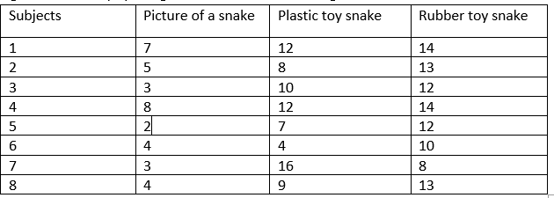

- What are the null and alternative hypotheses
$$H_{0}: μ_{picture} = μ_{plasticToy}= μ_{rubberToy}$$
$$H_{a}:At least two means are different$$

- What are the test statistic and p-value?
$$F-Value=19.36576$$
$$p-value=1e-04$$

- What decision can you make in the context?
The p-value is $1e-04$, which is significantly lower than our 𝛼-value of 0.05, so we reject the null hypothesis which suggests that there is evidence that the mean difference in physiologic response are significantly different among the three stimuli.

- If there is a significant difference, which two?
PlasticToy and Picture are significantly different with a p-value of <1e-04 and RubberToy and Picture are also significantly different with a p-value <1e-04.

- Consider an experiment on testing the efficiency of two drugs on lowering heart rate for heart disease patients. Eight patients are administered three drugs (one of them is the placebo control) at three different years and heart rate measured every five minutes for a total of four measurements. Suppose that the heart rates did not change significantly through the three years. That means there is no year effect on the experiment. Perform an appropriate test to examine the main effect of the drugs on lowering heart rate, the main effect of time and the interaction between drug and time. The data is given below:
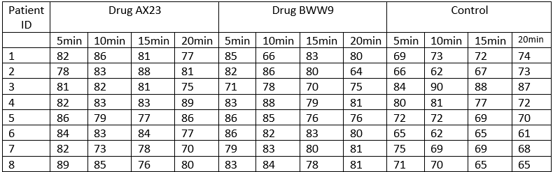
- Formulate the null and alternative hypotheses for testing the main effect of time.
$$H_{0}: μ_{5min} = μ_{10min}= μ_{15min}= μ_{20min}$$
$$H_{a}:At least two means are different$$

- What are the F-statistic and p-value for testing the main effect of time?
$$F-Value=0.019$$
$$p-value=0.9965$$

- What decision can you make for the main effect of time?
The p-value is 0.9965, which is significantly higher than our 𝛼-value of 0.05, so we fail to reject the null hypothesis which suggests that there is no evidence that the mean difference of time has any impact on heart rate.

- Formulate the null and alternative hypotheses for testing the main effect of drug.
$$H_{0}: μ_{AX23} = μ_{BWW9}= μ_{Control}$$
$$H_{a}:At least two means are different$$

- What is the F and p-value for testing the main effect of drug?
$$F-Value=8.656$$
$$p-value=0.0004$$

- What decision can you make for the main effect of drug?
The p-value is 0.0004, which is significantly lower than our 𝛼-value of 0.05, so we reject the null hypothesis which suggests that there is evidence that the mean difference between at least two drugs has an impact on heart rate.

- What are the F-value and p-value for the interaction term? What can you conclude about the interaction term (is it significant)?
$$F-Value=0.242$$
$$p-value=0.9610$$
The p-value is 0.9610, which is significantly higher than our 𝛼-value of 0.05, so we fail to reject the null hypothesis which suggests that there is no evidence that the mean difference between time and drug interaction has an impact on heart rate.

- If there are significant differences in the heart rate after taking different drugs, which two of drugs are significantly different?
Control and AX23 are significantly different with a p-value of 0.0197 and Control and BWW9 are also significantly different with a p-value 0.0498.

- Do a two-way repeated-measures ANOVA for the following data. We measured reading of the altimeters at two different temperatures (low and high) and measured the reading at four positions of altimeters (high, low, right, left). The DV is accuracy of altimeter reading. High scores show more accurate reading than low scores. Perform your analysis and answer the following questions to test the claim that there is a significant mean readings between the positions and between the temperature levels, and that there is a significant interaction between temperature and position.
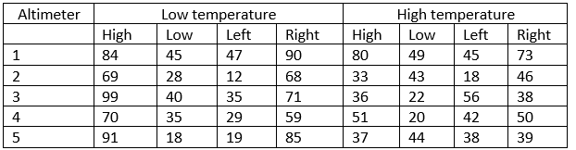

- Formulate the null and alternative hypotheses for testing the main effect of temperature on the accuracy of reading.
$$H_{0}: μ_{Low} = μ_{High}$$
$$H_{a}:μ_{Low} ≠ μ_{High}$$

- What is the F value and p-value for testing the main effect of temperature?
$$F-Value=10.62987$$
$$p-value=0.0029$$

- What decision can you make for that main effect of temperature?
The p-value is 0.029, which is significantly lower than our 𝛼-value of 0.05, so we reject the null hypothesis which suggests that there is evidence that the mean difference between high and low temperatures influences altimeter reading.

- What is the F and p-value for testing the main effect of position?
$$F-Value=22.19546$$
$$p-value=<.0001$$

- What decision can you make for the main effect of position?
The p-value is0.0001, which is significantly lower than our 𝛼-value of 0.05, so we reject the null hypothesis which suggests that there is evidence that the mean difference in at least two positions influences altimeter reading.

- What is the F and p-value for testing the interaction? What can you conclude about the interaction term (is it significant)?
$$F-Value=9.52772$$
$$p-value=0.0002$$

- If there is a significant interaction, separate the data by position and test whether there is a significant difference between the low and high temperature at each position. (list your t-statistic, p-value and conclusion for each position)
High
t = 3.2385, p-value = 0.03172
The p-value is 0.03172, which is significantly lower than our 𝛼-value of 0.05, so we reject the null hypothesis which suggests that there is evidence that mean levels are different between temperature at a high position.

Low
t = -0.28312, df = 4, p-value = 0.7911
The p-value is 0.7911, which is significantly higher than our 𝛼-value of 0.05, so we fail to reject the null hypothesis which suggests that there is no evidence that mean levels are different between temperature at a low position.

Left
t = -2.6825, df = 4, p-value = 0.05508
The p-value is 0.05508, which is significantly higher than our 𝛼-value of 0.05, so we fail to reject the null hypothesis which suggests that there is no evidence that mean levels are different between temperature at a left position.

Right
t = 3.9353, df = 4, p-value = 0.01703
The p-value is 0.01703, which is significantly lower than our 𝛼-value of 0.05, so we reject the null hypothesis which suggests that there is evidence that mean levels are different between temperature at a right position.

